You will need:

* Access to install software on your local machine
* A local copy of AdventureWorksDW

## Lab 02.A – Install the Self Hosted Integration Runtime locally

1. To start off, within Azure Data Factory, navigate to the “Integration Runtimes” section to register the new self-hosted runtime.

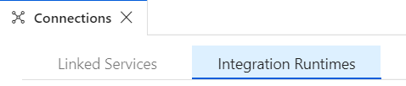

1. Here you can click the “New” button to create our new IR. You will be presented with the following options, we’re working with external computers, so select that option.

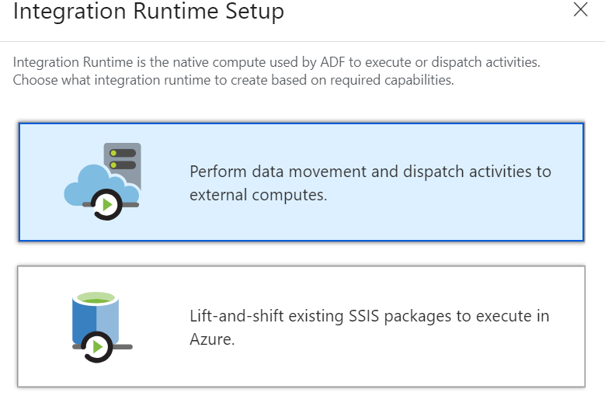

1. Next we need to confirm that we want to create a new Self Hosted IR, rather than other types of runtime:

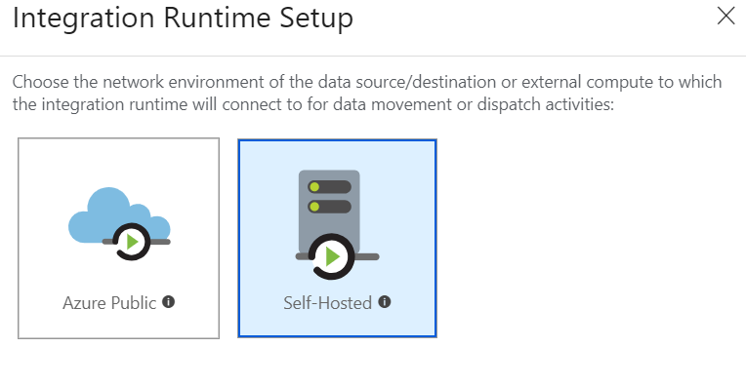

1. The next dialog allows us to either install an IR automatically, or install the application ourselves and register it. Let’s install it manually so you can see the registration process. Click “Download and Install integration runtime” and follow the options through.

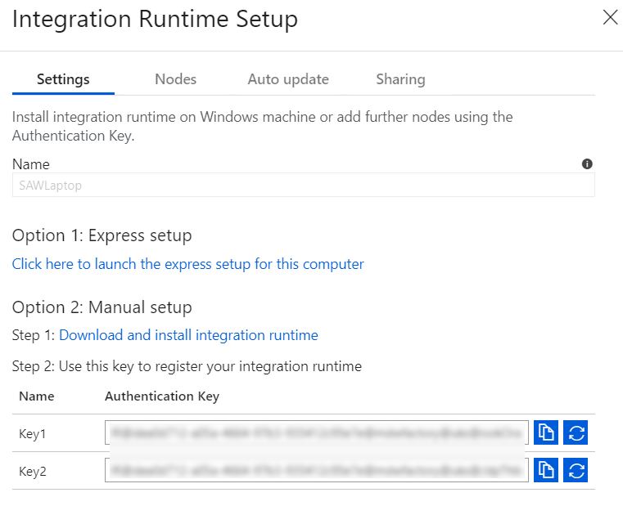

1. Once the SHIR has installed, you will be prompted for an Authentication key, these are the ones shown in step 4. Just take one and copy it in here.

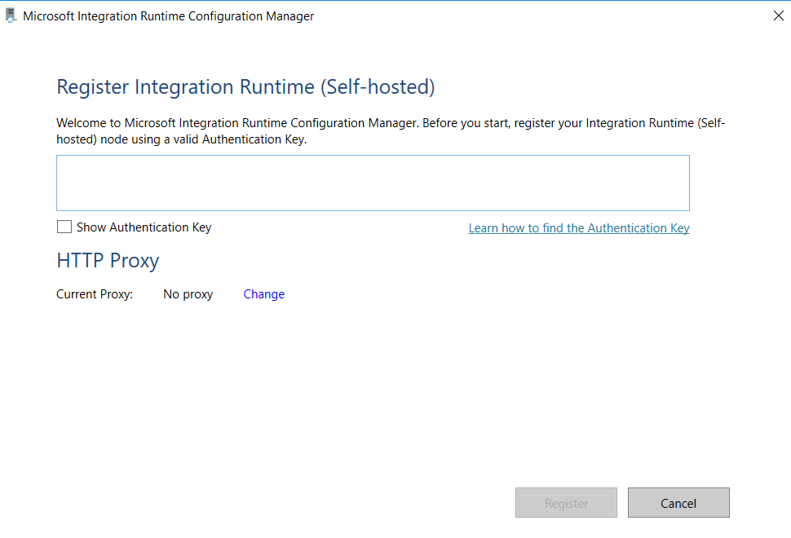

The key will be validated once entered:

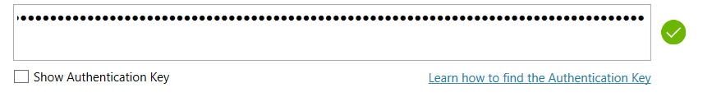

1. Confirm this and you will be prompted with a new SHIR registration:

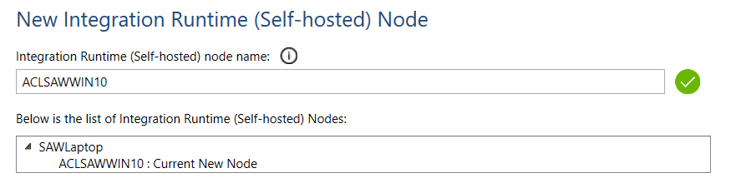

Confirm this and the HTTP Proxy setup will run, registering your local installation with the new Integration Runtime we created in ADF.

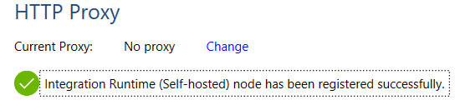

1. You can now run the Configuration Manager see more details about the local installation, but it is ready to start working with Data Factory!

## Lab 02.B – Register a local data source using the new SHIR

1. Let’s create a new linked service to take advantage of the Self-Hosted Integration Runtime. Head back to the Linked Services tab under “Connections” and click to add a new Linked Service.
2. Seach for “SQL Server” and click “Continue”

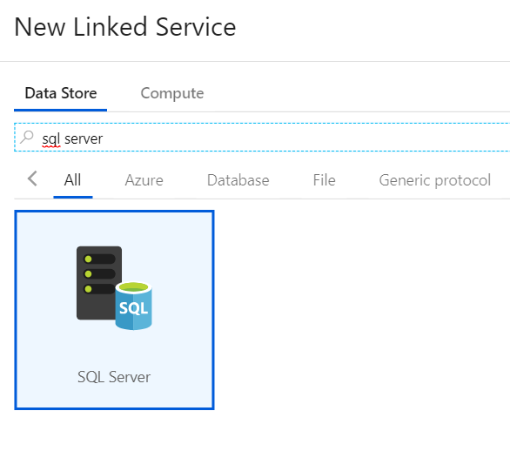

1. You will now be able to select your Self Hosted Integration Runtime under the “Connect Via Integration Runtime” option:

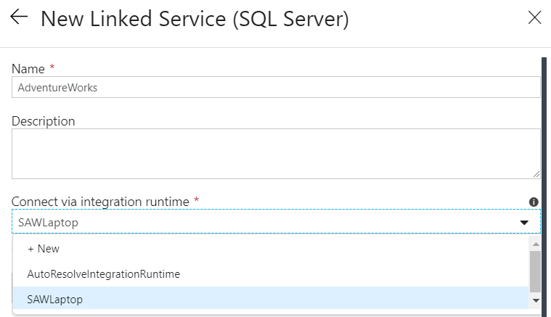

1. From here on, the connection can be defined as it would be on your local machine. For demonstration, I’ve used “.” as the server reference and a windows account. In production environments, you would always specify the full SQL address and use a service account.

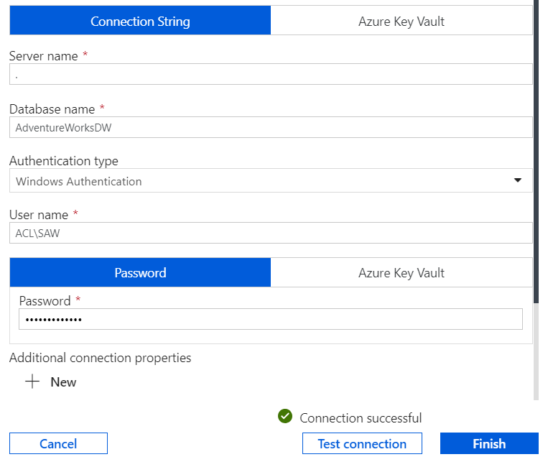

1. Click Finish and your new Linked Service is ready to go. We should now have linked services for our local SQL Server and the new Azure Data Lake Store Gen 2.
2. You should now be able to replicate the steps we went through in Lab 2, creating a copy data activity using your new Linked Service. You will need to create a dataset using the On Premise Linked Service first!